CREATE IBM WATSON IOT PLATFORM AND DEVICE

|  |  |
| --- | --- |
| **Team ID:** | PNT2022TMID02412 |
| **Project Name:** | GAS LEAKAGE MONITORING AND ALERTING SYSTEM FOR INDUSTRIES |
| **Team Members:** | Gowthamkumar  Lakshmi viyamesh  Hariprasad  Bharath Kumar |

**Steps for creating IBM Watson Cloud:**

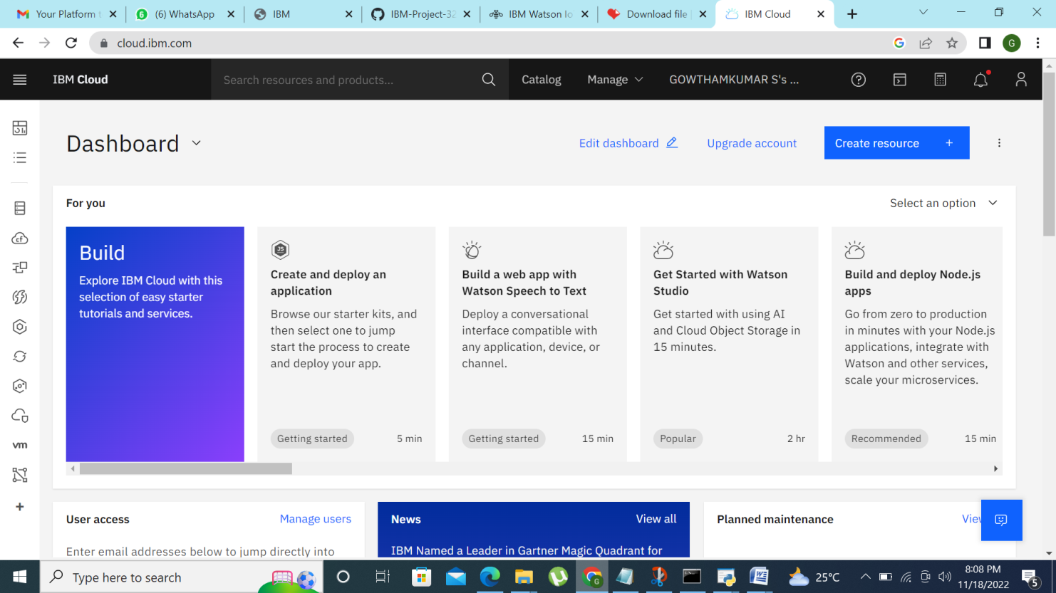

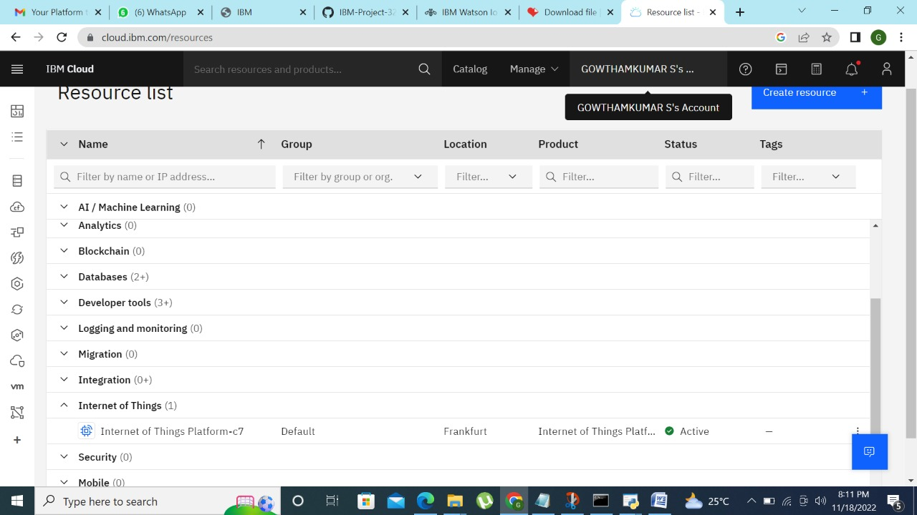

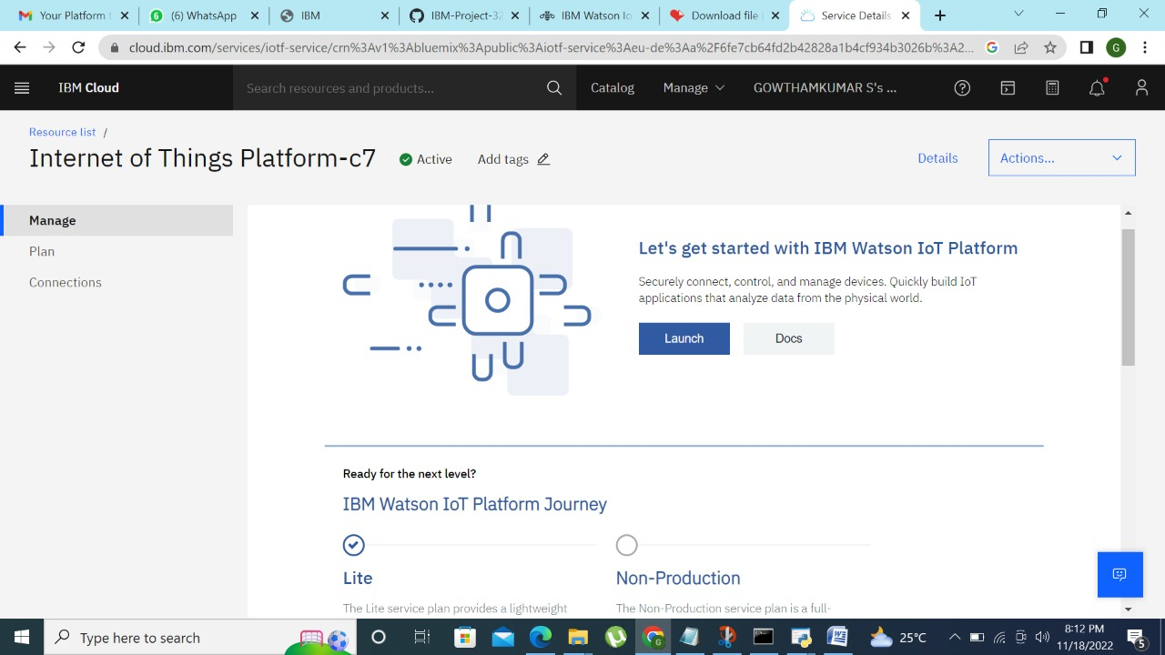

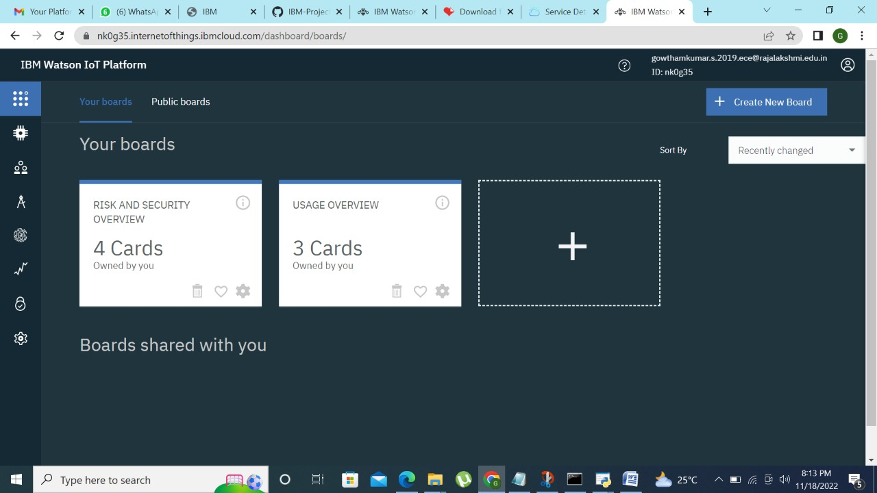

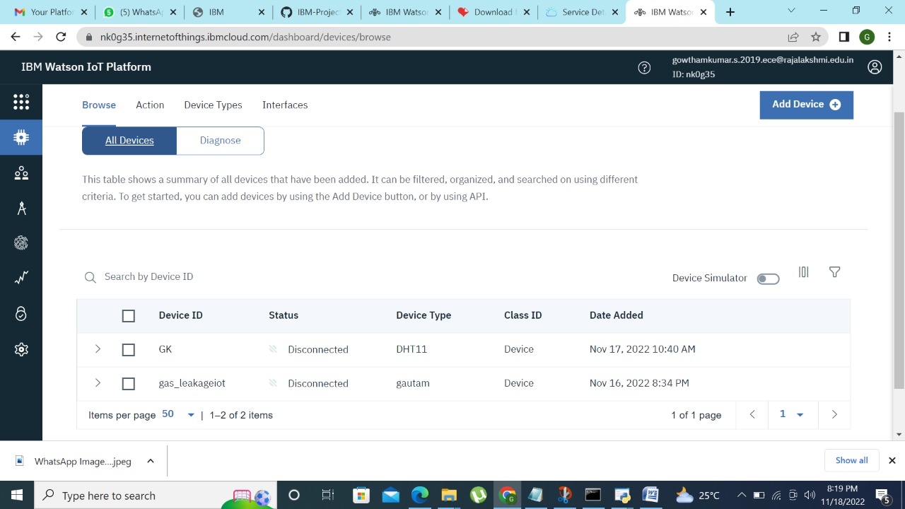

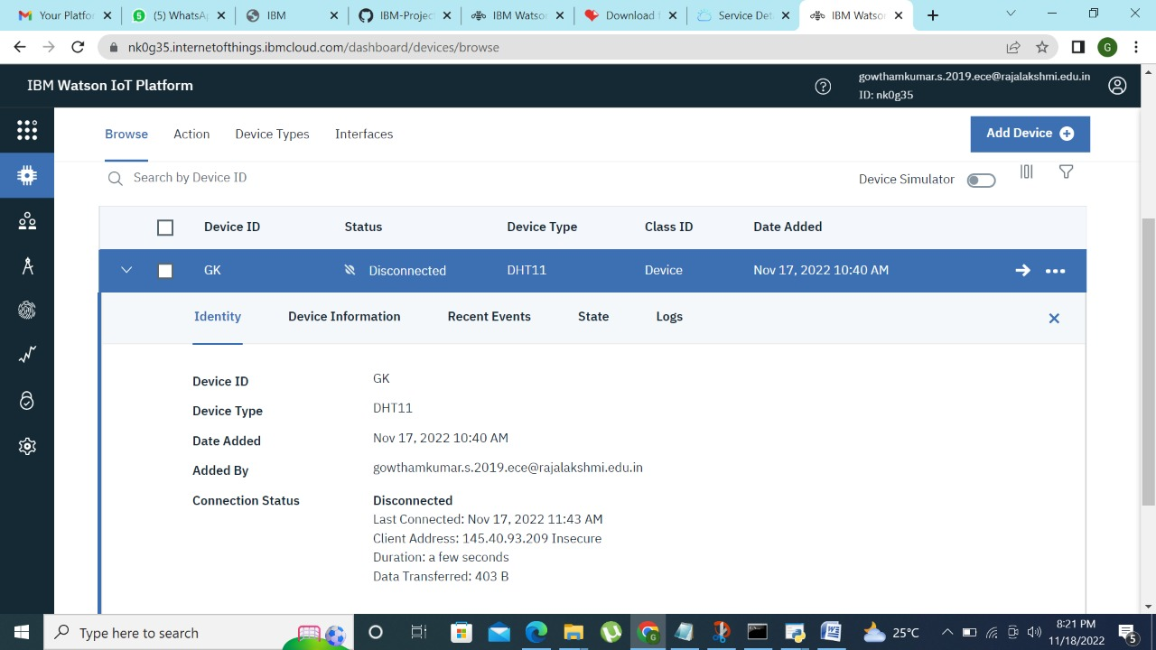

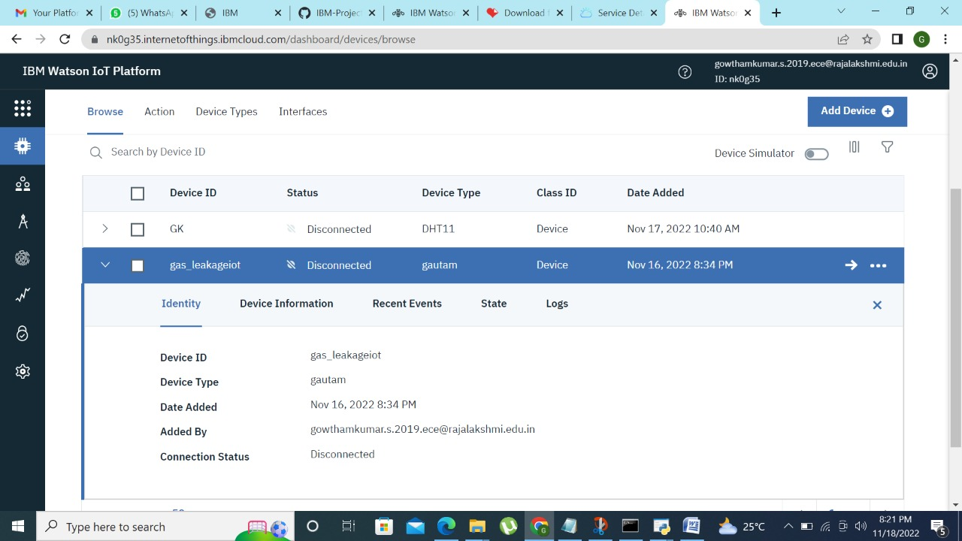

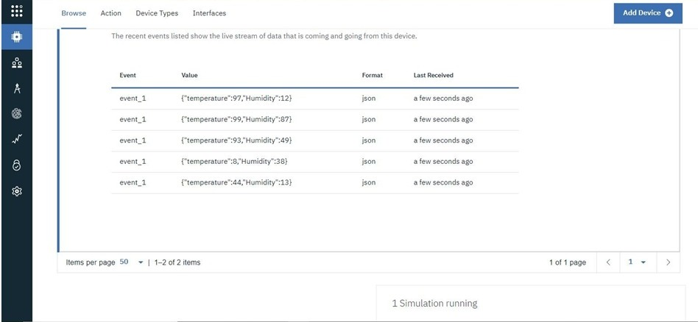

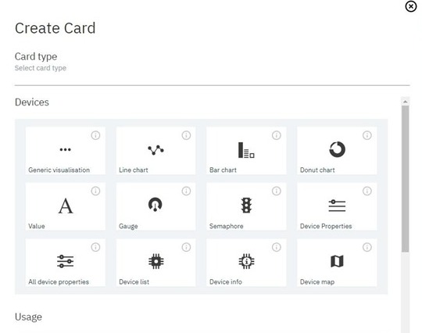

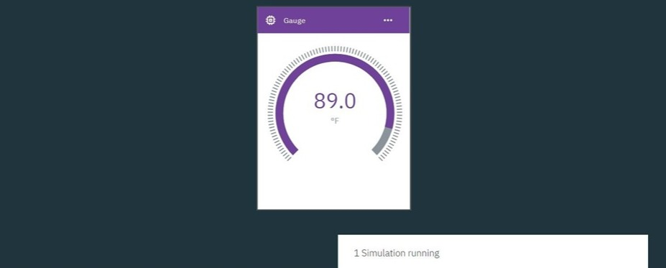

**Result:**

An IBM Watson Cloud for IOT and a device is created successfu